

Tank Level Warning Panel

RCALM3
RCALM3L
RCALM3Q
RCALM3LQ
RCALM3B
RCALM3LB
RCALM3QB
RCALM3LQB

Installation and Operation Manual

Table of Contents
Description Of Operation 2
Models 2
Installation 3
Safety Precautions 3
Included Components 3
Required Components Not Included 3
Layout 3
Control Panel Mounting 4
RCALM3/RCALM3Q 4
RCALM3L/RCALM3LQ 7
RCALM3B/RCALM3QB 10
RCALM3LB/RCALM3LQB 12
Operation 14
Safety Precautions 14
Usage 14
Specifications 14

Description Of Operation

The RCALM3 Display Panel provides a highly visible and reliable level indication and low level warning display for water tanks which do not need a precise level reading.

The illumination of one or more lights provides an indication of power supply status.

The red low level light alerts the user to a low tank level and is accompanied by a repeating buzzer and/or volt-free BMS connection (both optional) for audible and remote alert.

Models

RCALM3 | Light, Buzzer, BMS, 230vac Float Switch
RCALM3L | Light, Buzzer, BMS, 24vdc Float Switch
RCALM3Q | Light, BMS, 230vac Float Switch
RCALM3B | Light, Buzzer, 230vac Float Switch
RCALM3LQ | Light, BMS, 24vdc Float Switch
RCALM3LB | Light, Buzzer, 24vdc Float Switch
RCALM3QB | Light, 230vac Float Switch
RCALM3LQB | Light, 24vdc Float Switch

Installation

Safety Precautions
Mains Voltage – There are exposed electrical conductors inside this appliance. This appliance must be installed and serviced by a competent electrical technician to the current requirements of BS7671 and IEEE recommendations. Before servicing this appliance, normal safe isolation procedures should be implemented.

Do not touch any connection terminals while energised.

Do not attempt to service this item when wet, or in a wet or high humidity environment.

If the housing of the control panel becomes damaged, you must shut down and securely isolate this appliance immediately.

Included Components
RCALM3 Control Panel
Attached mains cable
Installation & Operation Manual

Required Components Not Included
2 x Float switch, at least 1 float switch must be 2 way or double acting (3 cores)

Layout
The control panel cannot be mounted outside, it is not fully weather resistant, but can be installed in sheltered outdoor locations (barns, covered areas, etc).

Suitable circuit protection must be installed and should include as a minimum a suitable earth, overcurrent protection, and residual current protection at 30mA, ideally on it's own circuit, but always in accordance with BS7671 and applicable regulations.

Control Panel Mounting
Open the cover of the control panel. There are 4 recesses, one on each corner of the panel. Drill through at these locations and attach to the wall or a suitable support, taking care not to damage cabling inside the panel. Fixings are not included and should be selected to suit the material to which the panel will be mounted.

RCALM3/RCALM3Q
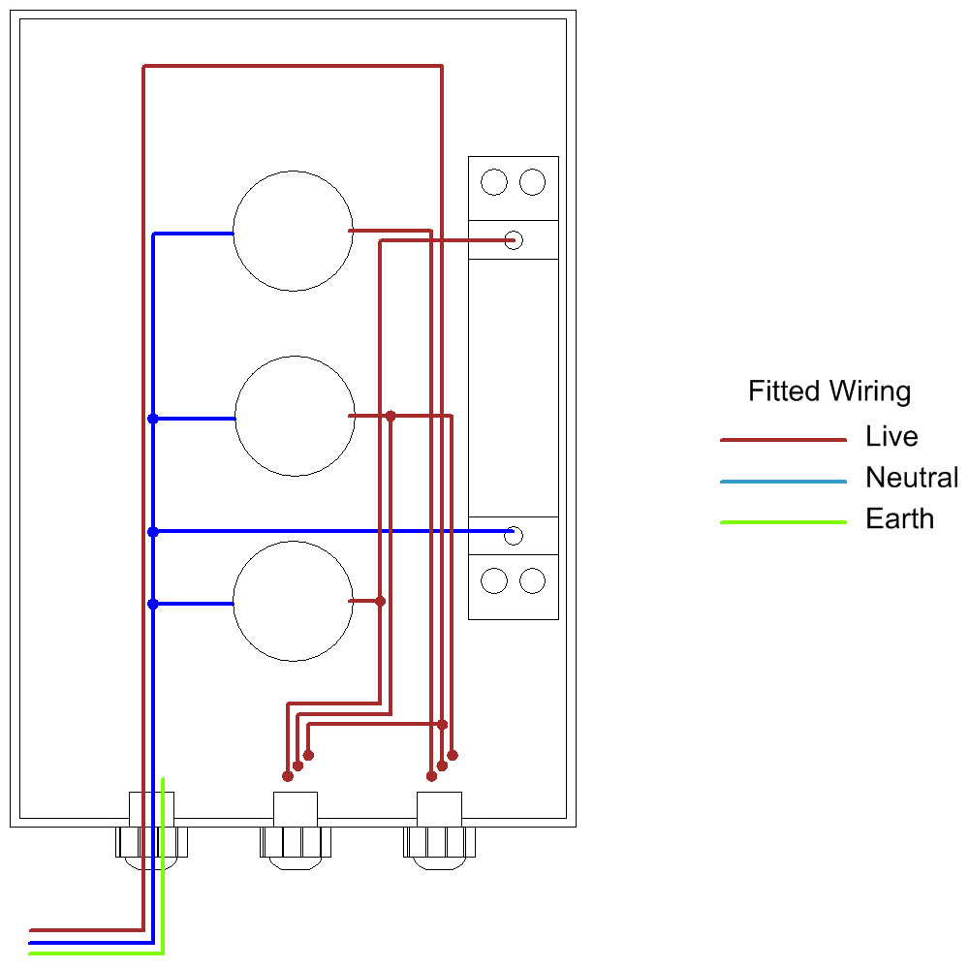

The control panel is supplied with wiring installed in the drawing shown above. The float or level switch needs to be fitted by one of the following methods, depending on whether the float/level switches are 1 way (2 wires) or 2 way (3 wires). A 2 way switch can switch the supplied voltage to one of 2 separate return wires depending on whether the float is oriented up or down.
Connections

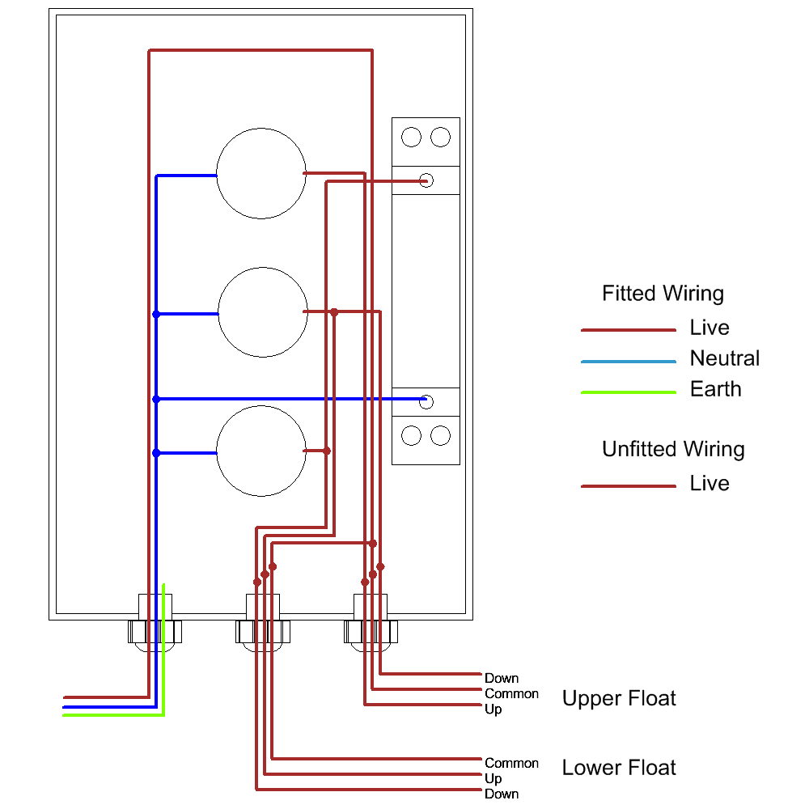

BMS Connection
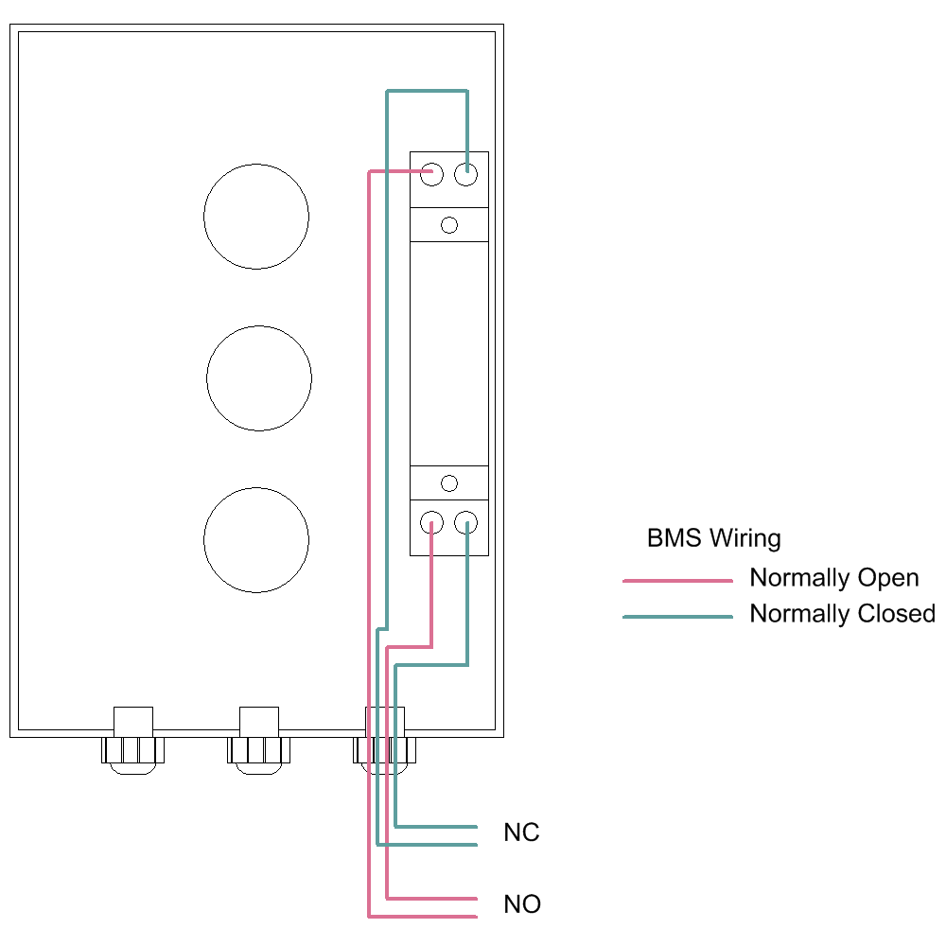

The lower float is wired with all 3 wires connected, the upper float uses only 2 wires to activate the green light. This achieves a sequence from full to empty of Green+Amber, Amber, Red.

Note that all wires to the float switch or level switch are live.

Note the green/yellow earth connection is provided for circuit protection to the appliance and has no function within the display panel which is Class 2 rated.

RCALM3L/RCALM3LQ

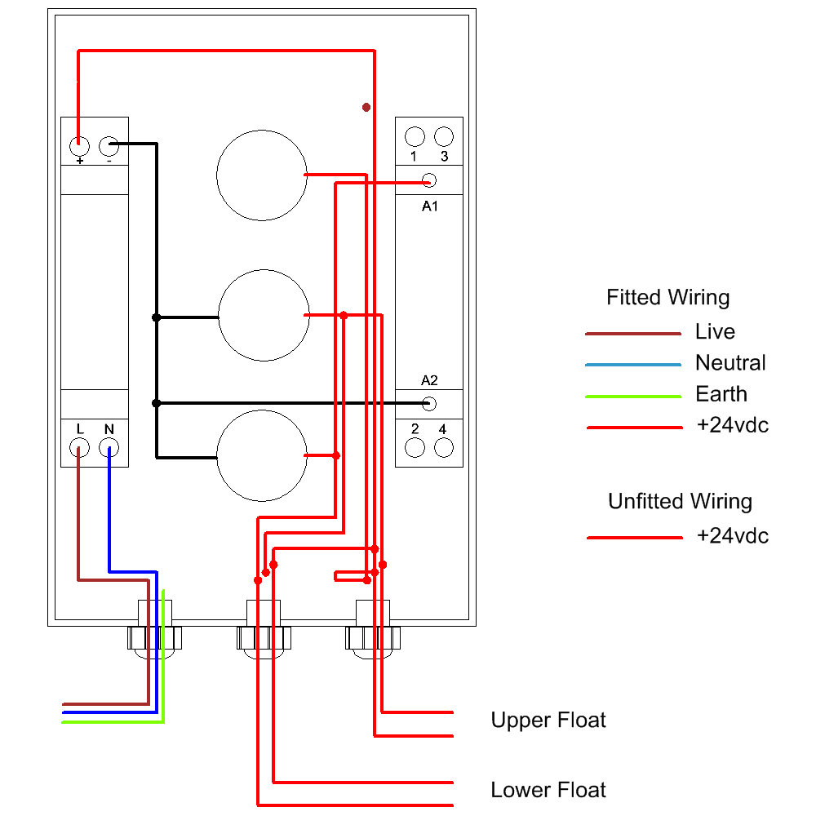

The control panel is supplied with wiring installed in the drawing shown above. The float or level switch needs to be fitted by one of the following methods, depending on whether the float/level switches are 1 way (2 wires) or 2 way (3 wires). A 2 way switch can switch the supplied voltage to one of 2 separate return wires depending on whether the float is oriented up or down.
Connections

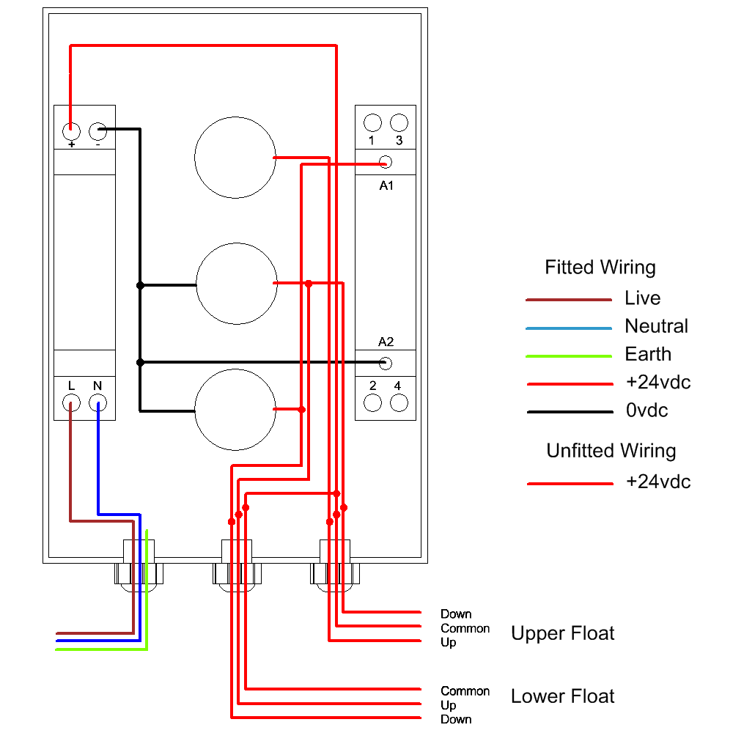

The lower float is wired with all 3 wires connected, the upper float uses only 2 wires to activate the green light. This achieves a sequence from full to empty of Green+Amber, Amber, Red.

Note that all wires to the float switch or level switch are live.

Note the green/yellow earth connection is provided for circuit protection to the appliance and has no function within the display panel which is Class 2 rated.

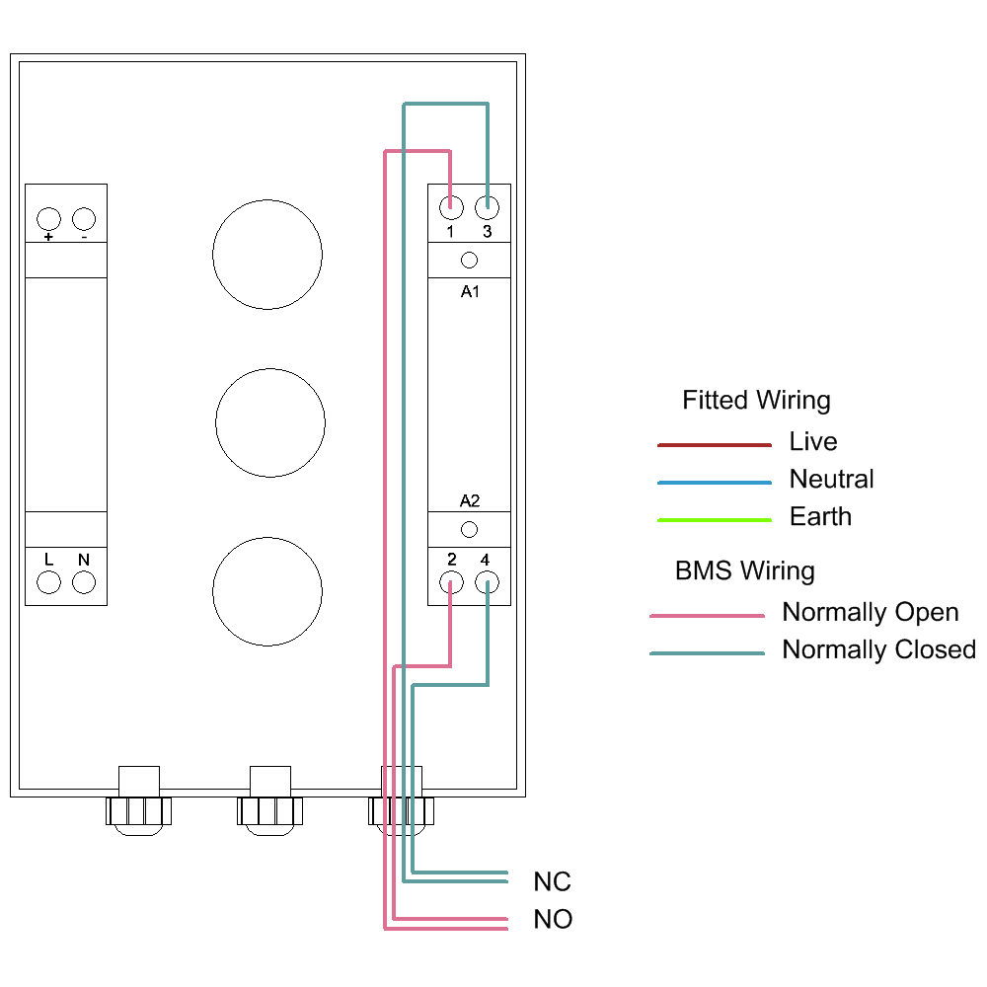

RCALM3B/RCALM3QB

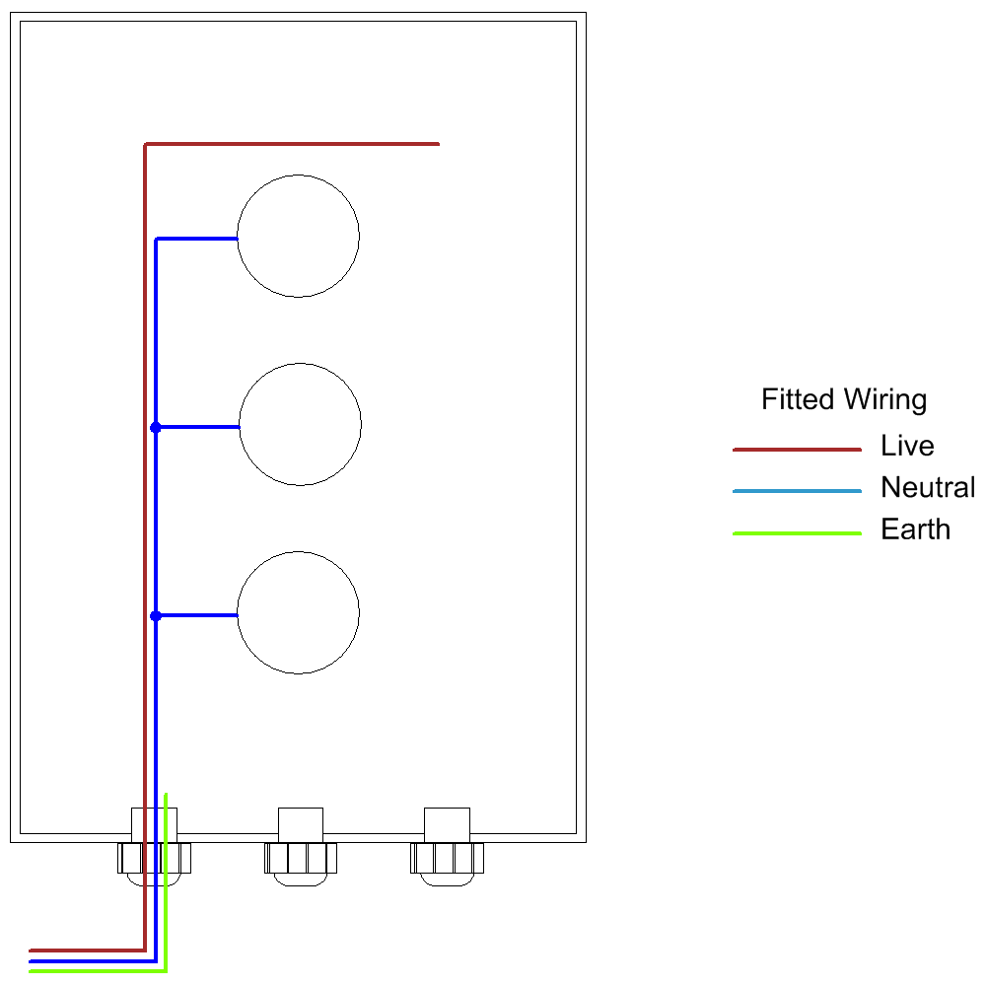

The control panel is supplied with wiring installed in the drawing shown above. The float or level switch needs to be fitted by one of the following methods, depending on whether the float/level switches are 1 way (2 wires) or 2 way (3 wires). A 2 way switch can switch the supplied voltage to one of 2 separate return wires depending on whether the float is oriented up or down.
Connections

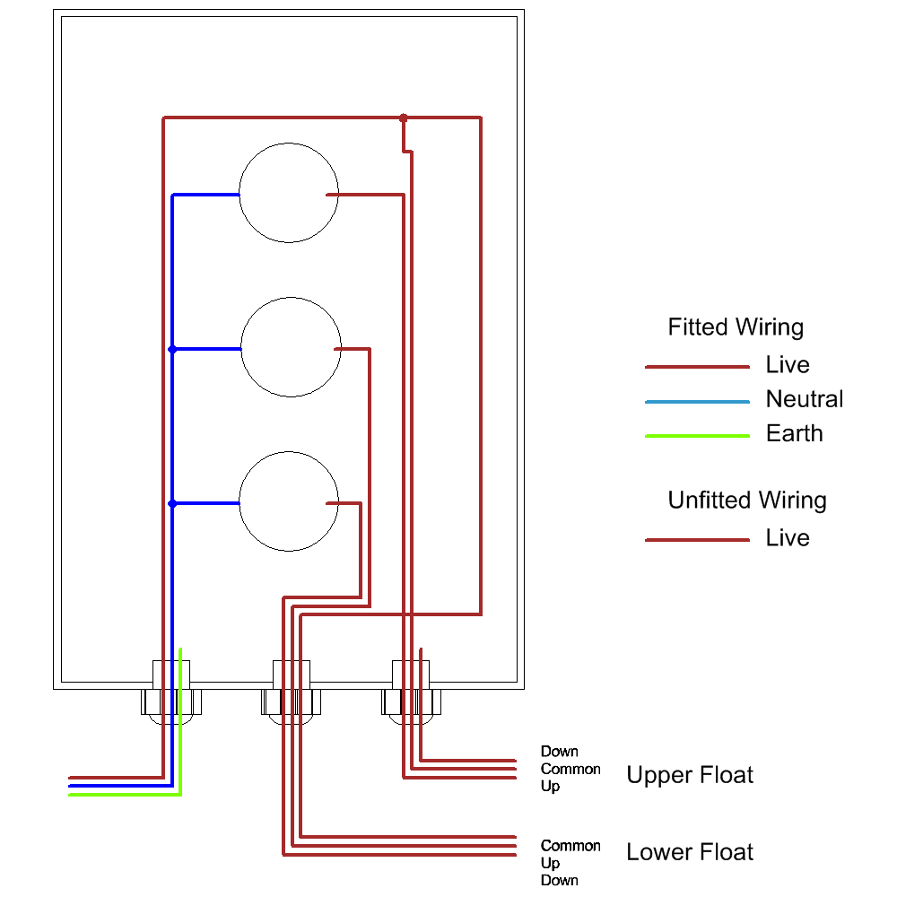

The lower float is wired with all 3 wires connected, the upper float uses only 2 wires to activate the green light. This achieves a sequence from full to empty of Green+Amber, Amber, Red.

Note that all wires to the float switch or level switch are live.

Note the green/yellow earth connection is provided for circuit protection to the appliance and has no function within the display panel which is Class 2 rated.

RCALM3LB/RCALM3LQB

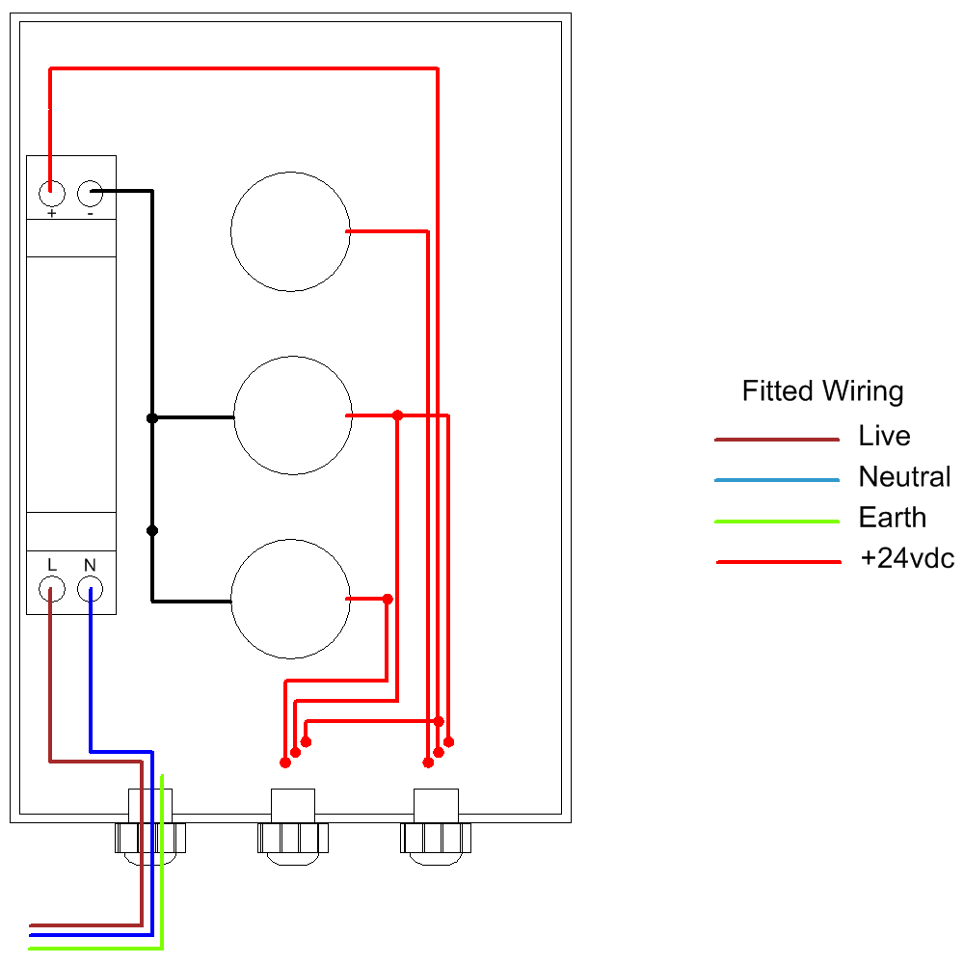

The control panel is supplied with wiring installed in the drawing shown above. The float or level switch needs to be fitted by one of the following methods, depending on whether the float/level switches are 1 way (2 wires) or 2 way (3 wires). A 2 way switch can switch the supplied voltage to one of 2 separate return wires depending on whether the float is oriented up or down.
Connections

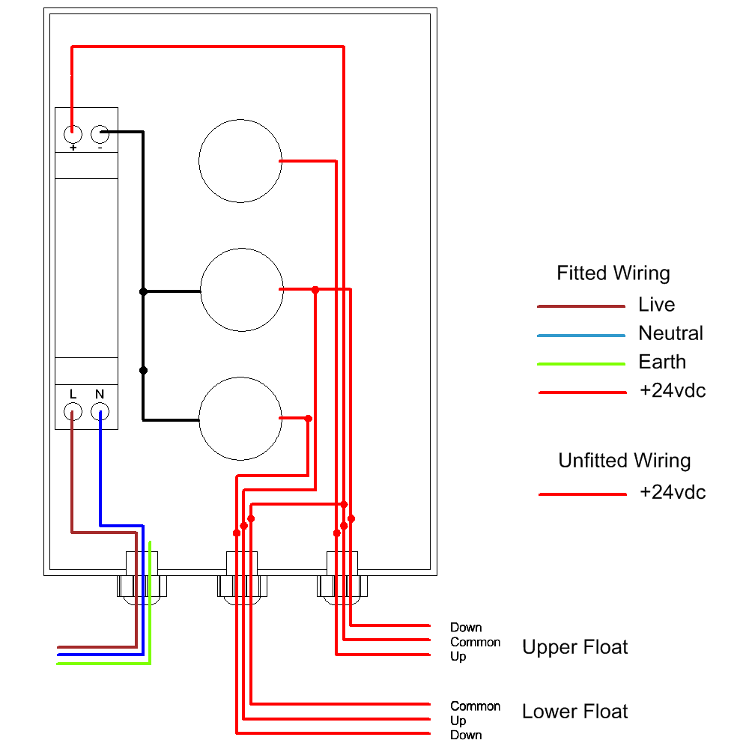

The lower float is wired with all 3 wires connected, the upper float uses only 2 wires to activate the green light. This achieves a sequence from full to empty of Green+Amber, Amber, Red.

Note that all wires to the float switch or level switch are live.

Note the green/yellow earth connection is provided for circuit protection to the appliance and has no function within the display panel which is Class 2 rated.

Operation

Safety Precautions
Mains Voltage – There are exposed electrical conductors inside this appliance. Before servicing this appliance, normal safe isolation procedures should be implemented.

Do not attempt to operate this item when wet, or in a wet or high humidity environment.

If the housing of the control panel or attached wiring becomes damaged, you must shut down and securely isolate this appliance immediately.

Usage

Once energised the display panel will show one or more lights. This indicates that the tank level is being monitored, and that there has been no disconnection or trip of any circuit breaker.
If all lights go out, check the circuit breaker at the consumer unit supplying this circuit. Reset if necessary. If the circuit trips again do not reset but instead have the system checked by an electrically qualified service agent or a qualified electrician.
The red light shows that the tank is at a low level, as indicated by the installed position of the float switch or level switch.

Specifications
Dimensions 180mm x 110mm x 90mm
Enclosure Material Polystyrene
Ingress Protection IP66
Electrical Protection Class 2
Voltage 230VAC 1~

